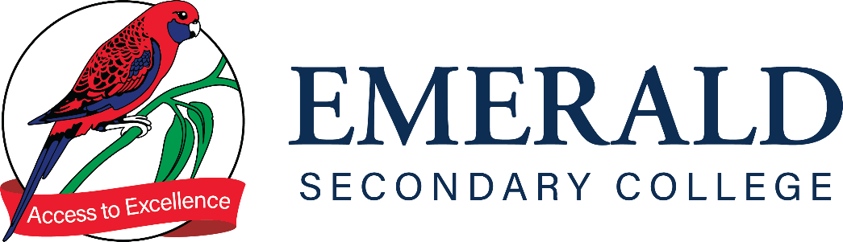

SUBMISSION OF WORK POLICY 7-10

Purpose
The purpose of this policy is to outline to our school community Emerald Secondary College’s policy requirements relating to student submission of work.

Scope

This policy applies to students in Years 7 to 10 and staff for setting and monitoring student assessment. For students undertaking a VCE/ VCE VM subjects, please refer to the Senior School Handbook.

RATIONALE
The submission of work is an integral part of the teaching and learning process. At Emerald Secondary College we have developed a process that is equitable and fair to all students and applied consistently across the College. The submission of work is crucial to the learning process, it enables both students and staff to identify areas of continual growth and improvement in each learning area.

Emerald Secondary College recognises that on occasion, meeting submission deadlines is difficult due to extended absence, illness and medical conditions. In such cases, students need to provide their teacher with a written explanation from their parent/carer which notifies the work will be submitted late, preferably 24 hours before the submission date. In the event of a student absence due to illness, the explanation can be submitted on their return.

Aims:
- To establish protocols and procedures that defines the process for students to submit class tasks, homework and assessments
- To ensure that students and parents understand the importance of completing and submitting class tasks, homework and assessments
- To provide a structured framework to identify students who require assistance in establishing a homework routine and/or who have difficulty in effectively managing time to meet deadlines.

Implementation:

Protocols and procedures
- The submission and time management of all assessment, school tasks and homework by the due date is the responsibility of the student.
- Work requirements will be clearly communicated to students via Learning Tasks, Compass and/or information distributed by the teacher
- All submitted material must be the student’s own work. Plagiarism and copying of other students’ work may result in sanctions (for more information, please refer to the ESC plagiarism policy)
- If the submission is handwritten, it must be legible and presented neatly with name of student, date and teacher written on the submission.
- Extensions will only be given by the teacher in respect of illness, medical condition, school approved absence or in exceptional circumstances. Students are advised that commitments outside of school are not sufficient reasons for an extension.

Late or Unsubmitted Work

In cases where students do not meet the deadlines for submission, the following steps will be taken in order for the late submission to take place:

Work Item | Action | Outcome
Classwork or Homework Task | - Students will be required to complete the work in a time set by the subject teacher (lunchtime or after school).  - Students will be informed by their subject teacher of the expected due date.  - The task and due date will be communicated by the teacher and documented in a Compass post. | - A new due date will be provided to the student  - Subject teacher will contact home  - If the student does not submit the work by the renegotiated deadline, the subject teacher will inform parents/carer/kin.  - Sub-School follow up may occur.
Common Assessment Task (CAT) | - Parents/carers/kin are advised via Compass Learning Tasks of the task and due date.  - Parents/carers/kin will be notified by the subject teacher if a student is absent or has not submitted the required task by the due date.  - In case of illness or approved absence, the subject teacher will provide student with a new deadline.  - In cases of non-submission or non-completion of task, the student will be required to submit a redemption task to demonstrate Victorian Curriculum Achievement Standards.  - Students are required to submit their redemptions within a 2 week time period from the initial conversation with their subject teacher. | - Student will complete the required redemption task in consultation with their subject teacher.  - Student will receive Satisfactorily Redeemed on their Learning Task if they have met the requirements of their redemption task.  - In the case of non-submission of the redemption task, the student will receive an NS for the task. The subject teacher will inform parents/carers/kin.  - Sub-school monitoring for progress and follow up will occur.

- In the case of a major assessment task such as a CAT (Common Assessment Task), Learning Engagement Leaders will be made aware of the Compass entry for future follow-up if deemed necessary.
- If a student continues to fail to meet due dates, and submissions are not made, then parents/carers/kin will be contacted and further action may be taken.

COMMUNICATION
This policy will be communicated to our school community in the following ways:
- Included in staff induction processes and staff training
- Available publicly on our school’s website
- Included in staff handbook/manual
- Reminders in our school newsletter
- Discussed at annual staff briefings/meetings
- Included in transition and enrolment packs
- Discussed at parent information nights/sessions
- Discussed at student forums
- Hard copy available from school administration upon request

POLICY REVIEW AND APPROVAL
Policy last reviewed | May 2023
Approved by | Principal
Next scheduled review date | May 2024

