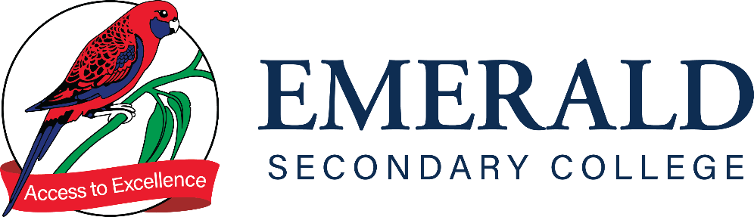

REDEMPTION POLICY 7-10

Purpose
The purpose of this policy is to outline to our school community Emerald Secondary College’s policy requirements relating to student assessment redemption in the case of an unsatisfactory result.

Scope

This policy applies to students in Years 7 to 10 and staff for setting and monitoring student assessment. For students undertaking a VCE/ VCE VM subjects, please refer to the Senior School Handbook.

RATIONALE
The redemption of work is an integral part of the teaching and learning process. At Emerald Secondary College we have developed a process that is equitable and fair to all students and applied consistently across the College. The redemption of work is crucial to the learning process, it enables both students and staff to identify areas of continual growth and improvement in each learning area.

Feedback is an integral part of the learning process, it is essential that students take teacher feedback on board and use this to demonstrate skills and understanding of the Victorian Curriculum standards in order to obtain a satisfactory result.

Aims:
- To establish protocols and procedures that defines the process for students to redeem an unsatisfactory assessment task.
- To ensure that students and parents understand the importance of redeeming an unsatisfactory assessment task.
- To provide a structured framework to identify students who require assistance in meeting the requirements of the curriculum.

Implementation:

Protocols and procedures
- The redemption of assessment is the responsibility of the student in consultation with the subject teacher.
- Redemption task requirements will be clearly communicated to students via Learning Tasks, Compass and/or information distributed by the teacher
- All redemption material must be the student’s own work. Plagiarism and copying of other students’ work may result in sanctions.
- If the is redemption task is handwritten, it must be legible and presented neatly with name of student, date and teacher written on the submission.
- Extensions will only be given by the teacher in respect of illness, medical condition, school approved absence or in exceptional circumstances. Students are advised that commitments outside of school are not sufficient reasons for an extension.

Redemption Process

In cases where students do not meet the requirements of assessment, the following steps will be taken in order for the redemption to take place:

Work Item | Action | Outcome
Common Assessment Task (CAT) | - Parents/carers/kin are advised via Compass Learning Tasks of the task and due date.  - Parents/carers/kin will be notified by the subject teacher if a student has not met the requirements of the assessment.  - The student will be required to submit a redemption task to demonstrate Victorian Curriculum Achievement Standards.  - Students are required to submit their redemptions within a 2 week time period from the initial conversation with their subject teacher. | - Student will complete the required redemption task in consultation with their subject teacher.  - Student will receive Satisfactorily Redeemed on their Learning Task if they have met the requirements of their redemption task.  - In the case of non-submission or unsatisfactory result of the redemption task, parents/carers/kin will be informed and the student will receive an N for the task.  - Sub-school monitoring for progress and follow up will occur.

Learning Engagement Leaders will be made aware of the need for redemption via the Compass entry for future follow-up if deemed necessary.

COMMUNICATION
This policy will be communicated to our school community in the following ways:
- Included in staff induction processes and staff training
- Available publicly on our school’s website
- Included in staff handbook/manual
- Reminders in our school newsletter
- Discussed at annual staff briefings/meetings
- Included in transition and enrolment packs
- Discussed at parent information nights/sessions
- Discussed at student forums
- Hard copy available from school administration upon request

POLICY REVIEW AND APPROVAL
Policy last reviewed | May 2023
Approved by | Principal
Next scheduled review date | May 2024

