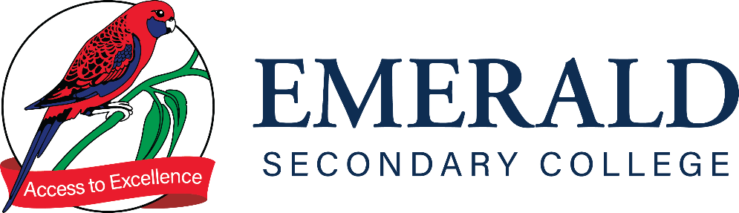

PLAGIARISM POLICY

Purpose
The purpose of this policy is to outline to our school community the Department’s and Emerald Secondary College’s policy requirements relating to plagiarism.

Scope

This policy applies to students in all year levels and staff for setting and monitoring student assessment. For students undertaking a VCE/ VCE VM subjects, this policy should be read in conjunction with the VCAA Assessment Policy available in the Senior School Handbook.

RATIONALE
At Emerald Secondary College we are committed to creating and sustaining a learning community where everyone continually learns and grows. To that end, we expect our students to take responsibility for their learning and progress. It is important to develop honest and ethical lifelong learning practices.

At Emerald Secondary College students are expected to submit their own work. ‘Plagiarism is a type of misconduct that, in some cases, may also give rise to copyright infringement. Plagiarism occurs where a student uses someone else’s ideas, images or words in their work and pretends they are their own. If the student has used a lot of someone else’s words without that person’s permission, copyright infringement may also occur.’ More information available at: https://smartcopying.edu.au/students-and-copyright/

What is Plagiarism? Plagiarism is considered to be intellectual theft. In the adult world there are serious legal consequences for this behaviour. At a school level, it is a form of cheating. Both Emerald Secondary College and VCAA have strict guidelines about the penalties that will be incurred when students are deemed to be cheating.

The following are considered as plagiarism:
- Copying out part/s of a document or image and presenting it as your own.
- Copying text or images straight from the internet or another source.
- Summarising somebody else’s work without acknowledgement of the source.
- Submitting a group assignment or another student’s work as your own.
- Sharing information on a test, homework, project or other assessment pieces.
- Passing on or receiving answers.
- Using sources: statistics, facts & expert opinions without reference.
- Having another person/s complete the work for you.
- Knowingly allowing others to copy your work.

Strategies to avoid plagiarism:

- Acknowledging your sources: statistics, facts & expert opinions strengthen your research, however, they must be referenced appropriately.
- Having a clear understanding of referencing conventions.
- Developing efficient and effective note taking strategies using your own words.
- Making sure you are organised with good time management skills in order to have enough time for referencing and proof reading.
- Ensure you understand the task, by clarifying exactly what is required with your teacher and how to appropriately research and construct your response.

Emerald Secondary College has developed this Plagiarism Policy in consultation with the School Council to support student learning and wellbeing by:
- providing opportunities for students to review, revise and reinforce newly acquired skills
- providing opportunities for students to apply new knowledge
- providing opportunities for students to prepare for future lessons
- encouraging students to enrich or extend knowledge individually, collectively and imaginatively
- fostering good lifelong learning and study habits
- supporting learning partnerships with parents/carers/kin.

POLICY

YEARS 7-10

Each incidence of plagiarism will be assessed by the relevant teaching staff member in consultation with appropriate Sub-School and/or member/s of the College Leadership.

Considerations may include:
- Nature of the plagiarism
- Level of intent
- Proportion of task plagiarised
- Circumstances relating to the plagiarism
- Prior incidents of plagiarism

The process of follow up includes:
- Notification made to relevant Sub-School.
- Potential breach investigated and discussed with student by subject teacher.
- Relevant teacher will communicate with parents/carers/kin regarding the incident.
- Teacher will log relevant information and document completion of work resubmission via a Compass Chronicle post.
- The student will be asked to resubmit the work to demonstrate knowledge and understanding of Victorian Curriculum Standards to gain a satisfactory redemption for this task.
- Students will be required to submit the work in an appropriate time designated by the classroom teacher. This may include: during class time, at a lunch time or at home under supervision.
- Students are expected to resubmit their task within two weeks of the initial discussion with their subject teacher.
YEARS 11 and 12

Plagiarism/ Copying
In line with breaching authentication, Emerald Secondary College has developed a policy for plagiarism offences on work in units of study other than official SACs and SATs. Teachers who suspect either of the above of a student in their class will bring evidence to the notice of the Senior School Leader. A panel will be convened, and students will be allowed to present information to assist them in their case. Students who are found guilty of submitting work that is plagiarised or copied on a first occasion will be required to complete an alternative task to meet the outcome, demonstrating the required skills and knowledge, however, they will receive zero for the assessment task. This has implications for passing the subject. Any students found guilty a second time in a year will receive an N for the unit in which the plagiarism was committed.

Possible Breach of Authentication
SACs and SATs are subject to VCAA authentication requirements – students must submit only their own work and acknowledge other influences in their work appropriately. Please note that the onus of proof here is on the student – they are required to supply drafts and evidence of background work in the event of an appeal.
The College Community will be notified of these rules by:
• Staff will be alerted by staff meetings and their handbook.
• Students will be alerted via this handbook, through other publications, and at assemblies.
• The wider school community will be informed through newsletter items and at VCE Information sessions.
Where a teacher is not satisfied that work submitted is the student’s own, they must notify the Senior School Leader and provide evidence. This should occur within 2 days of submission. This process may also be initiated as a result of allegations made by another student(s). The Senior School Leader will ensure that the process for breaches of this nature are followed correctly from this point as per the Handbook and will keep the teacher informed at each stage of the process.
The stages are as follows:
- Notification made to Senior School Leader or Assistant Principal (Teaching and Learning)
- Potential breach investigated
- If necessary, a notification of a formal interview with a Principal elected panel will be convened if there is sufficient reason to believe that a breach may have occurred.
- Where it is determined that a breach has occurred, the Principal (or nominee) will inform the student in writing of the penalty imposed and the provisions for appeal.
- Notification should be made within 14 days of the initial interview. The Senior School Leader will inform the VCAA of the breach according to their requirements. Students have the right to appeal the decision. Students in this situation should speak with the Senior School Leader if they intend to pursue this course of action.
Sanctions that may be applied as an outcome of Breaching Authentication can range significantly in severity. These can involve consequences including repeating a set task, to dismissal from all VCE programs. The final consequence depends entirely on the circumstances and nature of the offence. All such breaches are treated extremely seriously by the VCAA.

COMMUNICATION
This policy will be communicated to our school community in the following ways:
- Included in staff induction processes and staff training
- Available publicly on our school’s website
- Included in staff handbook/manual
- Reminders in our school newsletter
- Discussed at annual staff briefings/meetings
- Included in transition and enrolment packs
- Discussed at parent information nights/sessions
- Discussed at student forums
- Hard copy available from school administration upon request

POLICY REVIEW AND APPROVAL
Policy last reviewed | May 2023
Approved by | Principal
Next scheduled review date | May 2024

