School Strategic Plan 2021-2025
Emerald Secondary College (8707)

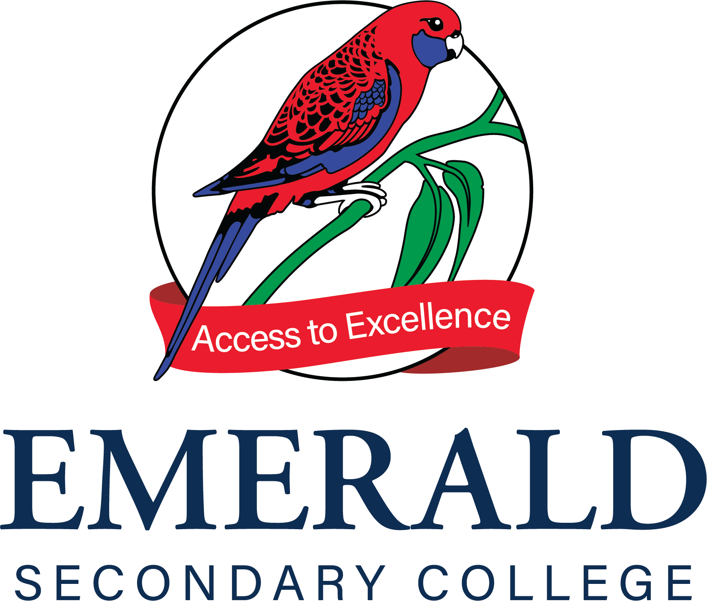

Submitted for review by James Barut (School Principal) on 08 November, 2022 at 01:22 PM
Endorsed by Scott Crawford (Senior Education Improvement Leader) on 08 November, 2022 at 01:30 PM
Endorsed by Nadia Beardshaw (School Council President) on 08 November, 2022 at 01:43 PM
School Strategic Plan - 2021-2025
Emerald Secondary College (8707)

School vision | Emerald Secondary College is a global learning community. We are committed to achieving excellence through positive relationships and personalised learning.
School values | At Emerald Secondary College all staff and students are expected to contribute to the attainment of the College’s five key objectives:  ? Achieve your potential  ? Build quality relationships  ? Cater for individual differences  ? Developing optimism  ? Encouraging endeavour
Context challenges | Emerald Secondary College is a single campus, co-educational college committed to ensuring that all our students experience a quality education that enables them to achieve their personal best and access excellence. Our school learning community aims to provide a caring, inclusive and sustainable environment in which students develop skills and personal qualities necessary to participate confidently and positively in a changing global world.  The college offers a comprehensive curriculum from Year 7 through to Year 12 and provides a 'Pathways for Success' approach to ensure all students achieve their personal best. As a college we prepare students for their future in an ever changing global landscape, which is supported through integrating ICT into our classrooms and teaching and learning practice.  Our college has a strong history of academic success with a high proportion of students being accepted into university or other tertiary institutions. We offer an extensive range of Victorian Certificate of Education (VCE) courses in the senior school complemented by vocational education opportunities including Vocational Education and Training (VET), Vocational Major (VM), and Victorian Pathways Certificate (VPC). We are also proud to be able to offer the Select Entry Accelerated Learning Program (SEAL) for academically talented students from Year 7 onwards. Students in the senior school have the opportunity to apply to accelerate in a subject if they meet benchmark standards, including accessing a first year University study to complement their senior VCE program where appropriate. Students also have access to Higher Education Studies (HES) offered by the Centre for Higher Education Studies (CHES).  We offer many opportunities for students beyond the Victorian Curriculum including our revitalised middle years curriculum, Instrumental Music program, School Productions and an extensive sports and Outdoor Education Program.  A challenge facing the College is embedding high aspirations into the culture so that students are empowered to actively engage in their learning to achieve to their potential. Therefore, a focus for the College is developing student voice and agency in learning. Our aim is to ensure that students recognise that they are being heard, develop their ability to take ownership of their learning and develop the resilience to become lifelong learners. Moreover, the introduction of an evidence based, explicitly taught, wellbeing curriculum will focus on meeting long term targets on School Connectedness, Self Regulation and Student Voice and Agency.
Intent, rationale and focus | Over the next four years, the College will focus on continually improving student outcomes, student engagement and wellbeing to ensure that all students can achieve their aspirations. The College plans to continue its focus on numeracy and literacy with an emphasis on writing at all year levels and in all learning areas to increase student achievement in all areas of the curriculum, including senior secondary outcomes VCE/VET/VM. To achieve this it is a priority to develop a common language and pedagogy around literacy and numeracy and consistent methods of assessment.  Increasing student motivation and engagement in their learning is also important as it will improve student outcomes and their sense of connectedness to the college and to their peers. Identifying the next step to advance their learning is important for students to progress academically and socially. Providing additional opportunities for students to take on leadership roles and give feedback on a wide variety of aspects of college life to improve their time at the College is seen as a means of achieving greater student engagement.

School Strategic Plan - 2021-2025
Emerald Secondary College (8707)

Goal 1 | Improve student learning
Target 1.1 | By 2025 increase the proportion of Year 9 students achieving above NAPLAN benchmark growth in writing from 18 per cent to 25 per cent and decrease the proportion of Year 9 achieving below benchmark growth from 26 per cent to 22 per cent
Target 1.2 | By 2025 increase perception of the School Staff Survey items for:  - Collective efficacy from 40 per cent positive endorsement in 2021 to 55 per cent  - Teacher collaboration from 47 per cent positive endorsement in 2021 to 55 per cent  - Academic emphasis from 33 per cent positive endorsement in 2021 to 45 per cent
Target 1.3 | By 2025 increase the proportion of students achieving a VCE study score of 37+ from 11 per cent in 2021 to 13 per cent
Target 1.4 | By 2025 increase the VCE mean study score from 28.7 in 2021 to 30.0
Key Improvement Strategy 1.a  Documented teaching and learning program based on the Victorian Curriculum and senior secondary pathways, incorporating extra-curricula programs | Continue to implement and support practices around the instructional model.
Key Improvement Strategy 1.b  Systematic use of assessment strategies and measurement practices to obtain and provide feedback on student learning growth, attainment and wellbeing capabilities | Improve understanding of formative assessment to implement a strategy to differentiate learning that meets students at their point of need.
Key Improvement Strategy 1.c  Documented teaching and learning program based on the Victorian Curriculum and senior secondary pathways, incorporating extra-curricula programs | Embed PLC processes that improve teaching practice and student learning.
Goal 2 | Improve student engagement
Target 2.1 | By 2025 increase perception of the School Staff Survey items for:  - Focus learning on real life problems from 38 per cent positive endorsement in 2021 to 50 per cent  - Promote student ownership of goals from 47 per cent positive endorsement in 2021 to 55 per cent  - Believe student engagement is key to learning from 81 per cent positive endorsement in 2021 to 88 per cent
Target 2.2 | By 2025 increase perception of the student Attitudes to School Survey items for:  - Motivation and interest from 44 per cent positive endorsement in 2021 to 50 per cent  - Self regulation and goal setting from 46 per cent positive endorsement in 2021 to 50 per cent  - Stimulating learning from 41 per cent positive endorsement in 2021 to 50 per cent  - Student voice and agency from 28 per cent positive endorsement in 2021 to 50 per cent  - High expectations of success from 64 per cent positive endorsement in 2021 to 75 per cent
Target 2.3 | By 2025 increase perception of the student Attitudes to School Survey items for  - Motivation and interest from 44 per cent positive endorsement in 2021 to 50 per cent  - Self regulation and goal setting from 46 per cent positive endorsement in 2021 to 50 per cent  - Stimulating learning from 41 per cent positive endorsement in 2021 to 50 per cent  - Student voice and agency from 28 per cent positive endorsement in 2021 to 50 per cent  - High expectations of success from 64 per cent positive endorsement in 2021 to 75 per cent
Key Improvement Strategy 2.a  Activation of student voice and agency, including in leadership and learning, to strengthen students’ participation and engagement in school | Embed the school re-engagement model to ensure all students are engaged in their learning
Key Improvement Strategy 2.b  Activation of student voice and agency, including in leadership and learning, to strengthen students’ participation and engagement in school | Research, develop and implement student leadership, voice and agency to improve student engagement to learning.
Key Improvement Strategy 2.c  Activation of student voice and agency, including in leadership and learning, to strengthen students’ participation and engagement in school | Develop the capability of middle leaders (domain and year level co-ordinators) to lead teams that improve student engagement
Goal 3 | Improve student wellbeing
Target 3.1 | By 2025 increase the perception of the Parent Opinion Survey items for:  - Promoting positive behaviour from 70 per cent positive endorsement in 2021 to 75 per cent  - Confidence and resiliency skills from 73 per cent positive endorsement in 2021 to 76 per cent
Target 3.2 | By 2025 increase the perception of the student attitude to school survey items for:  - Advocate at school from 57 per cent positive endorsement in 2021 to 65 per cent  - Teacher concern from 24 per cent positive endorsement in 2021 to 30 per cent  - Sense of connectedness from 34 per cent positive endorsement in 2021 to 42 per cent  - Resilience from 6 per cent positive endorsement in 2021 to 10 per cent
Target 3.3 | By 2025 improve student attendance for:  - Reduce students with more than 20+ days absence from 24% in 2021 to 10%.
Key Improvement Strategy 3.a  Responsive, tiered and contextualised approaches and strong relationships to support student learning, wellbeing and inclusion | Research and implement a whole school tiered wellbeing model
Key Improvement Strategy 3.b  Responsive, tiered and contextualised approaches and strong relationships to support student learning, wellbeing and inclusion | Build staff capacity and capability to engage with student’s wellbeing.

