School Bus Management System (SBMS)
Quick Reference Guide for New and Existing Travellers
The School Bus Program (SBP) assists students in regional and rural Victoria with travel to their nearest government or appropriate denominational school. This guide explains how your family can access the SBP through the online SBMS.
SBMS website: https://schoolbus.educationapps.vic.gov.au

New Travellers
1. Register an account  First time applicants for the School Bus Program will need to register an account. | 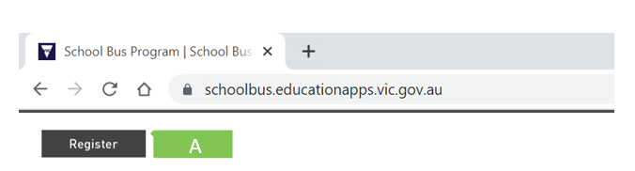  1
2. Add travellers  Travellers must be added to your account before an application to access the School Bus Program can be submitted. | 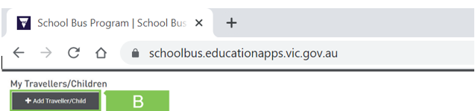  2
3. Create a new application  Once all travellers have been added to your SBMS account, you can go ahead and create new applications for travel for each traveller. | 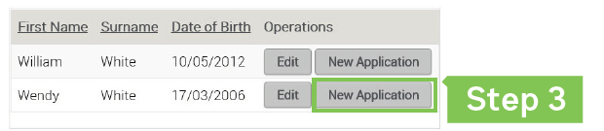  3  C
4. Manage Offer  When you receive a notification of your travel assessment details, you can choose to:  - Accept the offer and if applicable, pay the fare (students cannot travel until this step is complete), or  - Decline the offer. | 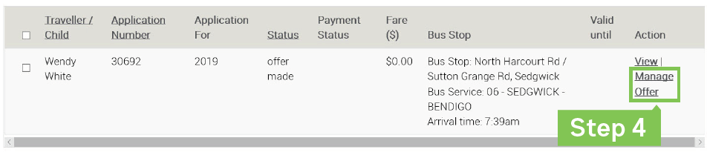  4

Existing Travellers
1. Login  If you are an existing user, you can login with your username and password.  In the event you have forgotten your password, click the Reset Password button and follow the steps to reset  the password.  If you have forgotten your username, please call 1800 338 663 or email SchoolBus@education.vic.gov.au for further assistance. | 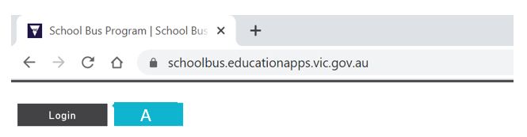  1
2. Manage your account  Update your personal information, including your address and emergency contact details. | 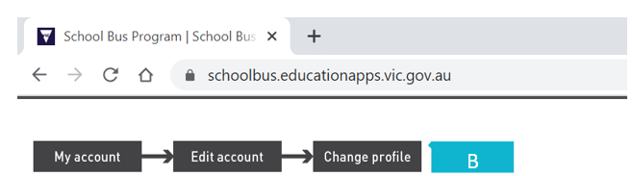  2
3. Renew Applications  If a traveller's circumstances have not changed (e.g. the address and school remain the same), the application must be renewed rather than creating a new one.  Renewing an application will ensure that the existing travel conditions are maintained.  If you have moved address or your child has enrolled at a different school, please update your details and create a  new application – see step 3 on page 1. | 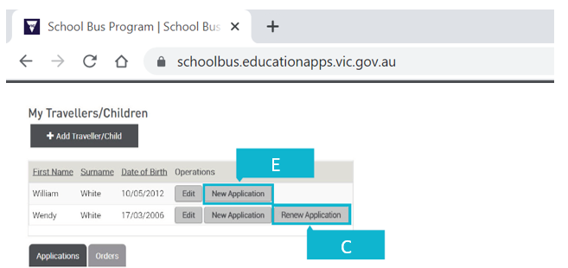  3  3
D. Manage Offer  When you receive a notification of your travel assessment details, you can choose to  - Accept the offer and if applicable, pay the fare (students cannot travel until this step is complete), or  - Decline the offer. | 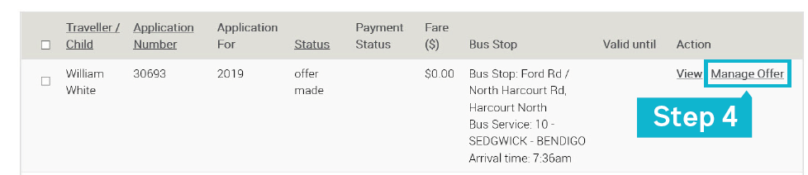  4

